

**CONVOY PROJECT**

**FINAL REPORT**

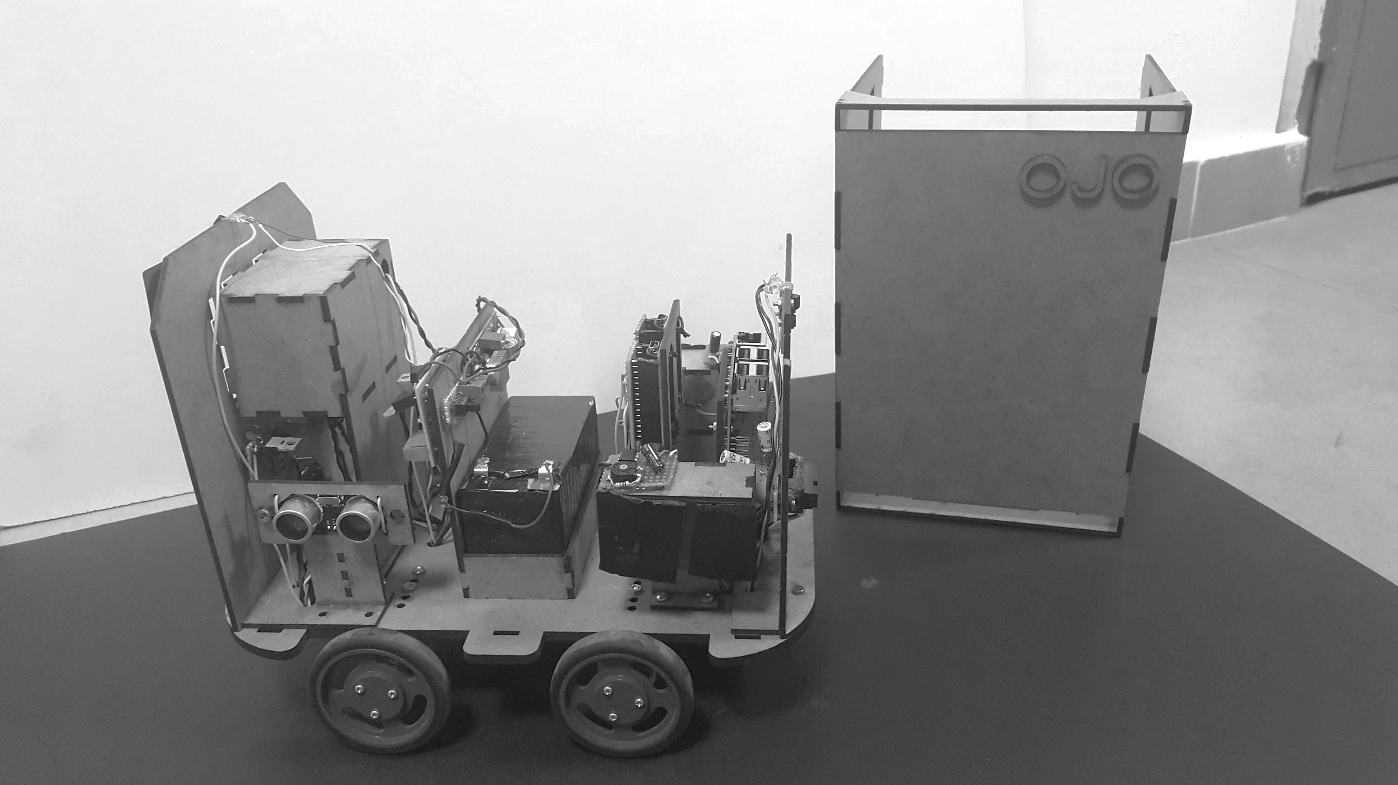

**Project Coordinator: Emre Özkan**

**Group Members:**

**Abdullah Aslam**

**Anar Abdullayev**

**Bulut Ulukapı**

**Syed Saad Saif**

**Umut Can Serçe**

**INTRODUCTION** **3**

Basic Information 3

Company Information 3

Profiles of the Members 3

**EXECUTIVE SUMMARY** **4**

**DESIGN DESCRIPTION** **5**

System and Subsystem Level 5

Main Controller 7

Control Library 7

Flags 7

Sensor Library 8

Direction Sensor 8

Front, Side and Back Distance Sensors. 8

Motors and Drivers 8

External Leave Command 8

Power System 8

Image Processing 9

Visibility Marker Detection 9

Leaving Signal 12

All Control and Data Signals with Their Feedback Paths 12

**OVERALL CIRCUIT DIAGRAM** **13**

**TECHNICAL DETAILS** **14**

Overall System Specifications 14

Module Specifications 14

**TESTS AND RESULTS** **16**

Image Processing 16

Green Rectangle Detection 16

Accuracy and precision of distance, direction and orientation. 16

Distance Sensors 18

IR Distance Sensor 18

Ultrasonic Distance Sensor 19

Solar Panel 20

Robot Speed 21

Turning 22

Leaving 22

Following 23

Power Delivery 24

**DELIVERABLES** **24**

**BUDGET** **25**

**IMPACTS OF THE ROBOT** **25**

Safety Issues 25

Lasers 25

Fire hazard 26

Widespread Applications 26

Virtual Sensor 26

Image Processing 26

Communication 26

Environmental Impact 27

Autonomy of the Car 27

Choice of Materials 27

**CONCLUSION** **27**

**APPENDICES** **28**

User Manual 28

Photos of the Robot 30

# INTRODUCTION

## Basic Information

This report is about the Convoy Project implementation of OJO. It contains information about the company and its shareholders, the design requirements, solutions, design specifications, technical details, tests and experiments with the results, budget analysis, possible widespread applications for the system or subsystems, some possible effects on the environment and safety issues. It also includes the list of deliverables as the outcome of the project and a user manual for the end user. All the topics mentioned in this paragraph are explained in detail in the corresponding parts of the report.

## Company Information

OJO is a company of five electrical and electronics engineers dedicated to provide innovative and effective solutions to contemporary engineering problems. We believe in simple solutions and proper planning. We fully embrace the 21st century and utilise modern computer programs to complement our design process wherever possible. This approach is clearly reflected in our work.

### Profiles of the Members

**Abdullah Aslam** is a fourth year electrical and electronics engineering student with good intellect. He has worked on control systems such as unmanned aerial vehicles (UAV) and has experience with programing languages.

**Anar Abdullayev** is a fourth year electrical and electronics engineering student who is specializing on computer division. He has experience with arduino, pic and arm based microcontrollers programming, motion sensors and communication interface.

**Bulut Ulukapı** is a fourth year electrical and electronics student on computer division who is interested in machine learning and experienced with various programming languages and microcontrollers. He is also experienced with HDLs.

**Syed Saad Saif** is a fourth year electrical and electronics engineering student who is specializing on control division. He has experience in microcontroller based discrete time feedback controllers. He is well versed in C programming language and object oriented programming. He can design PCBs as well.

**Umut Can Serçe** is a fourth year electrical and electronics engineering student who is specializing on computer division. He is experienced with various programming languages, HDLs and CAD softwares.

# 

**Figure 1:** Profiles of the members

# EXECUTIVE SUMMARY

The company OJO has started its journey in September 2017 with five shareholders. The aim of the company was not only to keep up with the latest advancement in today’s technology but also to make contribution to these advancements and even become one of the leading technology companies. The main motivation of the people of OJO to accomplish this is to help creating a better world by innovative technology solutions to existing problems.

In the convoy project, OJO combined it’s innovative approach with great team work in order to reach the goals of the company. To overcome the problems and hardships, different approaches for the solutions were analyzed in terms of efficiency and robustness in full accordance with the requirements and standards.

To realize the robot as a whole system, a systematic study has been conducted. First off all, subsystems were designed separately. Later on, each of them got tested to ensure their validity of the solution. Lastly, combined subsystems were put to tests to observe and correct the problems that can emerge between subsystems during integration.

At the end of the project, company OJO is pleased with its product. The company is confident that the robot will be very popular among the customers. Also the robot can be one of the milestones that leads the way to autonomous cars which can have groundbreaking applications and implementations for example people with disabilities and senior citizens.

# DESIGN DESCRIPTION

## System and Subsystem Level

Behaviours of the vehicle are described in different levels. Figure 2 illustrates the most general functional flowchart of the robot.

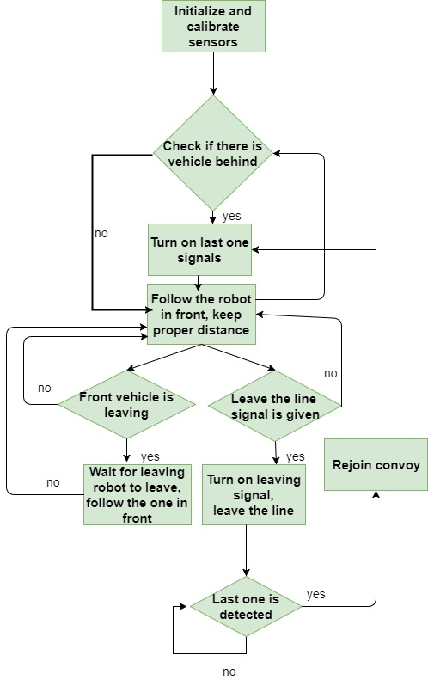

**Figure 2:** Simplified block diagram

To achieve the functions mentioned in Figure 2, different sensors, actuators and other parts are required to be mounted on the chassis of the robot. Figure 3 describes the relationship between the main parts.

.

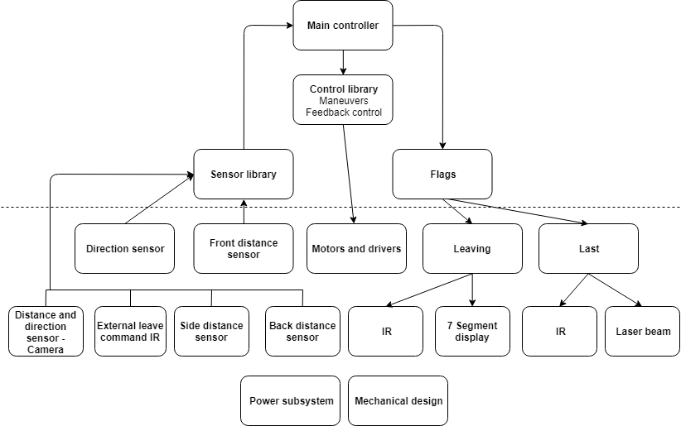

**Figure 3:** Overall description of the system

Note that, the parts below the dashed line are physical, and the rest are implemented in the software. The main controller takes all the information from the sensor library and choose the proper maneuvers for the robot and control the flags accordingly. Explicit behaviours of the main controller is described in Figure 4.

### Main Controller

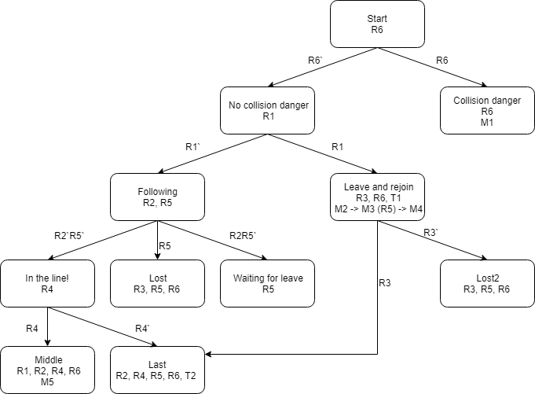

**Figure 4:** States of the main controller

The information mentioned in the states of the main controller is coded and explained in Table 1.

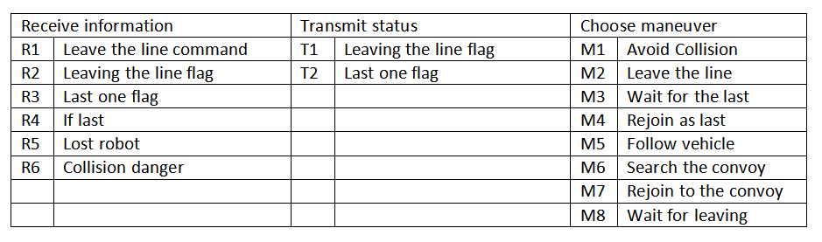

**Table 1:** Explanation of the codes

### **Control** L**ibrary**

The control library holds the codes of the maneuvers and feedback control. Output of this library drives the motors.

### **Flags**

The vehicle has two kind of flags and controlled by the main controller. Both leaving and last one flags implemented in two ways. The first leaving flag is a special signal defined in the standards and be transmitted by the power IR LED. This LED will be driven by the constant current circuit using LM317 regulator. The second leaving flag is formed by displaying figure 8 on a seven segment display which is placed on the back of the robot. One of the last one signals will also be transmitted by the IR LED. The other signal is laser beam. Two lasers will be placed on the sides of the robot and they will be detected by the solar panels.

### **Sensor** L**ibrary**

The sensor library is used to combine the information delivered by different sensors. Because of the requirement that all the signals needed to be given in two different ways, they will also be received by different sensors. The distance information can be obtained from camera and the IR distance sensor. If both sensors return proper information, sensor library will take average according to the coefficient of the trust value of the sensors. If only one sensor is operating, the sensor library will return that value. For the following part, sensor library will choose only one method at a time, which are either camera or IR direction sensor according to the distance information obtained from these two sensors.

### **Direction** S**ensor**

The direction sensor consisted of the two IR receiver LEDs placed in front of the robot. According to the light intensity, voltage level on the analog pin of the arduino will be changed and from the voltage difference, the direction will be deduced. There will also be another infrared sensor to detect the modulated IR signal.

### **Front,** S**ide and** B**ack Distance** S**ensors.**

In the front of the robot, the IR distance sensor will be used. The information delivered by this sensor is important for following the robot with proper distance. The ultrasonic distance sensor will be used in the back of the robot for testing if there is any vehicle behind or not. This information will inform the main controller if the vehicle is the last one or not. In the sides of the robot, ultrasonic sensors will also be used. To prevent crashes, the main controller will use the distance information delivered from all the sensors.

### **Motors and** D**rivers**

The vehicle has four motors. Two mosfets are used to drive the motors. To turn the vehicle, differential drive principle is applied. Both motors on the left or on the right are driven by the same signal.

### **External** L**eave** C**ommand**

External leave the line command will be given by the generic remote control, and will be received by the IR detector. Received signal will be processed by the Arduino.

### **Power** S**ystem**

To power up the device, 12V lead acid battery is used. Also to achieve 5V voltage level which is required for powering Arduino, Raspberry Pi and other sensor, a DC-DC converter is used.

### **Image** P**rocessing**

This module is responsible for the detection of the visibility marker and determination of the leaving signal. Moreover, it is also responsible for measuring the distance, determining the direction and orientation of the front robot with respect to our robot. The output of this module, which is the relative distance, direction angle and orientation angle of the front robot with our robot is send to sensor library.

This module processes the information captured by the camera, of our robot, in real time. By applying some algorithms on cameras feed we can achieve our goals. We used OpenCV library on Python platform for coding and then the code was implemented on Raspberry Pi 3.

#### **Visibility Marker Detection**

For the visibility marker detection, the aim is to first filter the green color out from the cameras feed and then apply the shape detection algorithm for rectangle detection. For green color detection, the cameras feed, which is in RGB, is converted to HSV. Then it is blurred to reduce noise. The upper and lower bound for green color is defined and a mask is created, which is applied on the blurred video. The purpose of the mask is to extract only the green color in the video. Let’s call the result obtained after green color detection as ‘result’. For rectangle detection, canny edge detection is applied on the result and then contours in the result are found. Then the shape detection code from OpenCV library is applied. Which determines the vertices of the shape and approximates the shape as rectangle if four vertices are found. After the green rectangle is detected, only the rectangle that satisfies the visibility marker specifications is considered. Then the corners of the rectangle are found, and using them, height, width, right edge height and left edge height and center of mass of the rectangle (visibility marker) are determined. This information is then used to calculate the relative distance, direction and orientation information of the front robot (visibility marker). Figure 5 shows the output feed of the camera and end result screen after our code is applied.

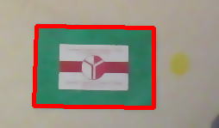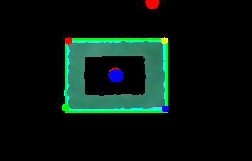

**Figure 5:** Output of camera (left), result after applying algorithm(right)

There are two critical cases that are considered.

**Case 1:** Plane containing camera is parallel with the plane containing visibility marker.

In this case the visibility marker looks like a rectangle in 2D projection (on the screen). It might be at an angle from the camera and this angle is defined as direction angle (α). If the visibility marker is directly in front of the robot then α is zero.

**Case 2:** Plane containing camera is **not** parallel with the plane containing visibility marker.

This implies that the front robot is rotating (in clockwise or anti-clockwise direction) with respect to the plane of camera. Therefore orientation angle (β) is defined as the angle between visibility marker’s plane and camera’s plane. In this case the visibility marker is observed as a trapezium in 2D projection.

Considering the above cases we obtain the required information. Figure 6 shows 2D projection of both cases.

  

**Figure 6:** Case 1 (left) and Case 2: rotating left (right image), rotating right (middle image)

For the relative distance information, average of left edge height and right edge height of the visibility marker is used. We use trigonometry and pinhole camera approach to determine the distance between the front robot and our robot. Figure 7 shows the typical pinhole camera approach and the Equation 1 shows the formula.

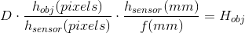

**Equation 1:** Formula for the actual distance calculation

Where,

D is the actual approximate distance between the visibility marker and our robot,

Hobj is the actual height of visibility marker,

hobj(pixels) is the average height in 2d projection of visibility marker,

hsensor(pixels) is the height of the frame in pixels,

hsensor(mm) is the height of sensor in mm and

f(mm) is focal length in mm.

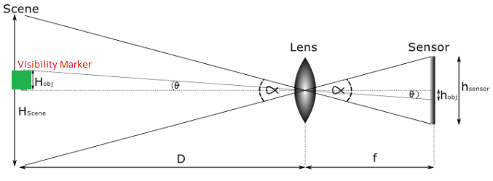

**Figure 7:** Pin hole camera approach

For the relative orientation angle (β), we use the ratio (r) of right edge height (reh) of the visibility marker to the left edge height (leh) of the visibility marker, r=reh/leh. If r=1, case 1, then β = 0. For r≠1 (case 2), orientation is anti-clockwise if r<1 and orientation is clockwise if for r>1. The values of ‘r’ are mapped onto another scale which is from -100 to +100, which is the scale for the angles defined for the control library of our robot’s. -100 being extreme anti-clockwise orientation, +100 being extreme clockwise orientation and 0 if orientation is zero. Figure 8 (left) shows the orientation angle.

For the relative direction angle (α) information, we use center of mass information of the visibility marker for both cases mentioned above. Also, we normalize the frame of camera such that the center of the frame is at origin. The idea is that the center of mass of the visibility marker should be at the origin of camera’s frame. Thus, the direction angle is more specifically defined as how much the visibility marker (front robot) is deviated from the origin in horizontal axis. Again, the horizontal axis (x-axis) information is mapped from -100 to +100 in similar way. -100 being the extreme left direction, +100 being the extreme right direction and 0 if at origin(α=0).Figure 8 (right) shows the direction angle.

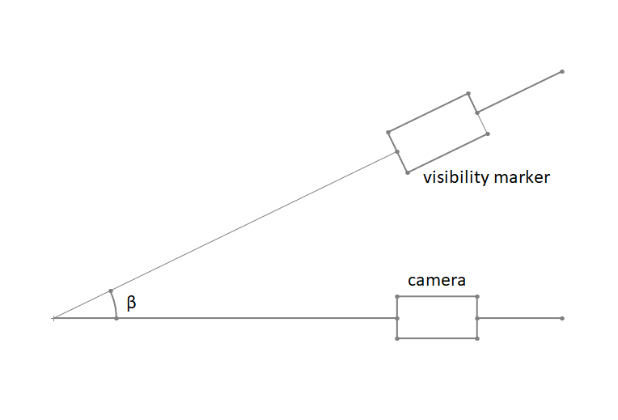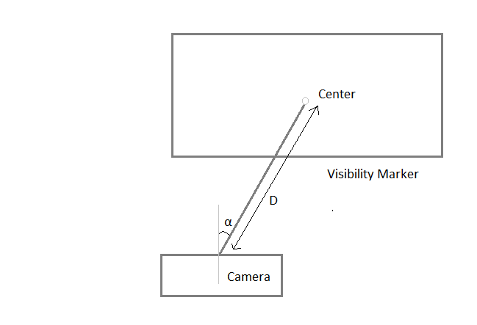

**Figure 8:** The orientation angle (left) and the direction angle (right)

#### Leaving Signal

For the determination of leaving signal we use color detection, but this time within the visibility marker. By considering the area inside the visibility marker only, we ignore any other color outside the area. Then, we use red color detection in a similar way with the green color detection for visibility marker. If red color is found, that implies the front robot is giving leaving signal. Hence, the module gives the status of the leaving signal to the sensor library.

## **All Control and Data Signals with Their Feedback Paths**

The slash on the data lines indicates that there are two channels of information.

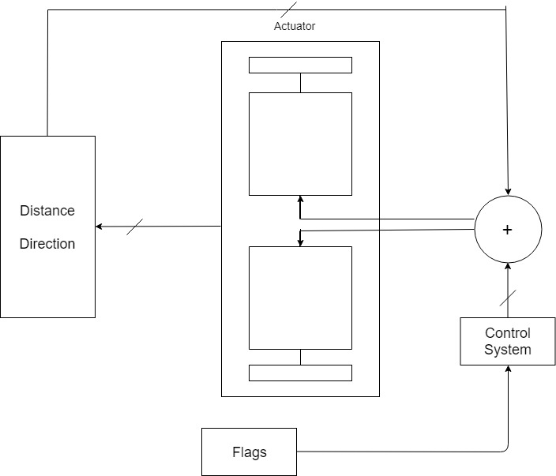

**Figure 9:** Control datapath overview

# OVERALL CIRCUIT DIAGRAM

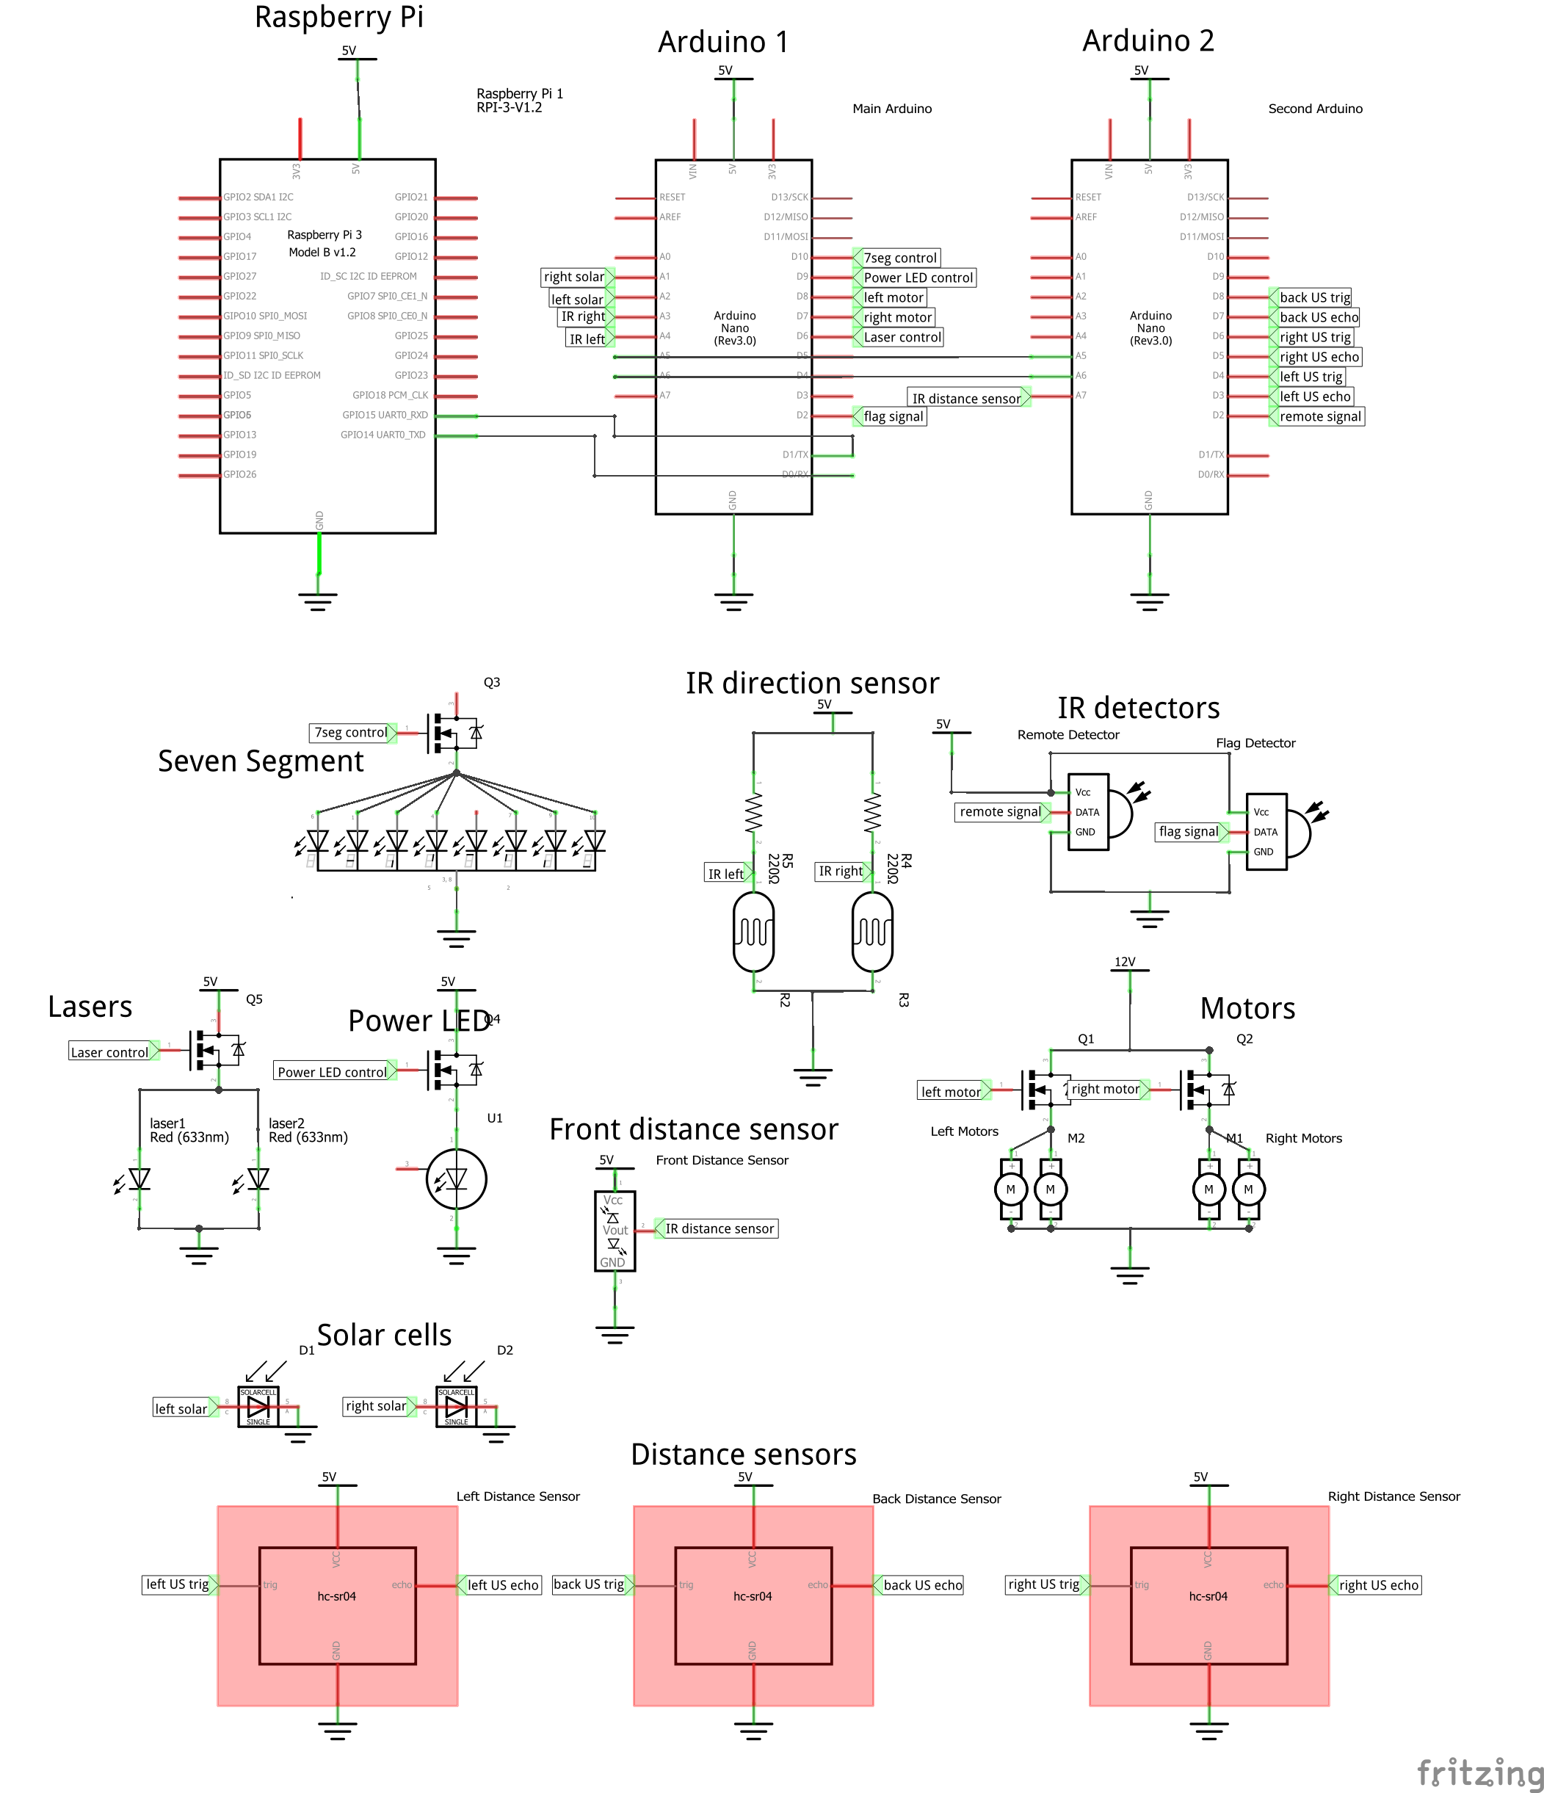

**Figure 10:** Overall Circuit Diagram

# TECHNICAL DETAILS

## Overall System Specifications

* Maximum Speed: 46 cm/s
* Average power consumption:
* Height: 23 cm
* Length: 26 cm
* Width: 18 cm
* Weight: 2.9 kg

## Module Specifications

**Arduino Nano:**

* Flash Memory: 32 KB
* SRAM: 2 KB
* EEPROM: 1 KB
* Clock Speed: 16 MHz
* Operating Voltage: 5 V
* 14 Digital I/O Pins (6 of them PWM Digital I/O Pins), 6 Analog Input Pins

**Raspberry Pi 3:**

* CPU: 4× ARM Cortex-A53, 1.2GHz
* GPU: Broadcom VideoCore IV
* RAM: 1GB LPDDR2 (900 MHz)
* Networking: 10/100 Ethernet, 2.4GHz 802.11n wireless
* Bluetooth: Bluetooth 4.1 Classic, Bluetooth Low Energy
* Storage: microSD
* GPIO: 40-pin header, populated

**Ultrasonic Distance Sensor:**

* Operating Voltage: 5 V DC
* Current: 15 mA
* Frequency: 40 Hz
* Distance measuring range: 2 to 400 cm

**Infrared Distance Sensor:**

* Distance Measuring Range: 10 to 80 cm
* Type: Analog Output
* Supply Voltage: 4.5 to 5.5 V
* Current: 30 mA

**Infrared Direction Sensor:**

* Distance Measurement Range: 10 to 80 cm
* Judgement Distance: 24 cm
* Supply Voltage -0.3 to 7 V

**Laser:**

* Optical Power Output: 10 mW
* Light Output Wavelength: 670 nm

**Solar Panel:**

* Nominal Voltage: 0.5 V
* Peak Current Current: 0.28 A
* Peak Power Production: 0.25 W

**Camera:**

* Still Resolution: 5 Megapixels
* Sensor resolution: 2592 x 1944 pixels
* Sensor Image Area: 3.76 x 2.74 mm
* Pixel Size: 1.4 μm x 1.4 μm
* S/N Ratio: 36 dB
* Focal length: 3.60 mm +/- 0.01
* Horizontal Field of View: 53.50 +/- 0.13 degrees
* Vertical Field of View: 41.41 +/- 0.11 degrees

**XL4015 DC-DC Step-Down Converter:**

* Voltage Regulating Mode: PWM
* Input Voltage: 8 to 36 V DC
* Output Voltage: 1.25 to 32 V DC
* Maximum Output Current: 5 A
* Output Power PMOS : 60 W
* Maximum Conversion Efficiency: 96 %
* Switching Frequency: 180 KHz

**Motors:**

* Size: 25 D x 52L mm
* Weight: 88 g
* Shaft Diameter: 4 mm
* Gear Ratio: 46:85:1
* Free-run Speed at 12 V: 210 RPM
* Free-run Current at 12 V: 300 mA
* Stall Current at 12 V: 5600 mA
* Stall Torque at 12 V: 1.65 N-m

# TESTS AND RESULTS

## **Image Processing**

**Objective:** Visibility marker detection and leaving signal determination, reliable distance, direction angle and orientation angle measurement.

**Possible sources of errors:**

* Environmental light

### Green Rectangle Detection

**Test Procedure:**

* Different colored shapes are placed on a board.
* Different green colored shapes are also placed.

**Test Results:** In Figure 11, the results can be observed.

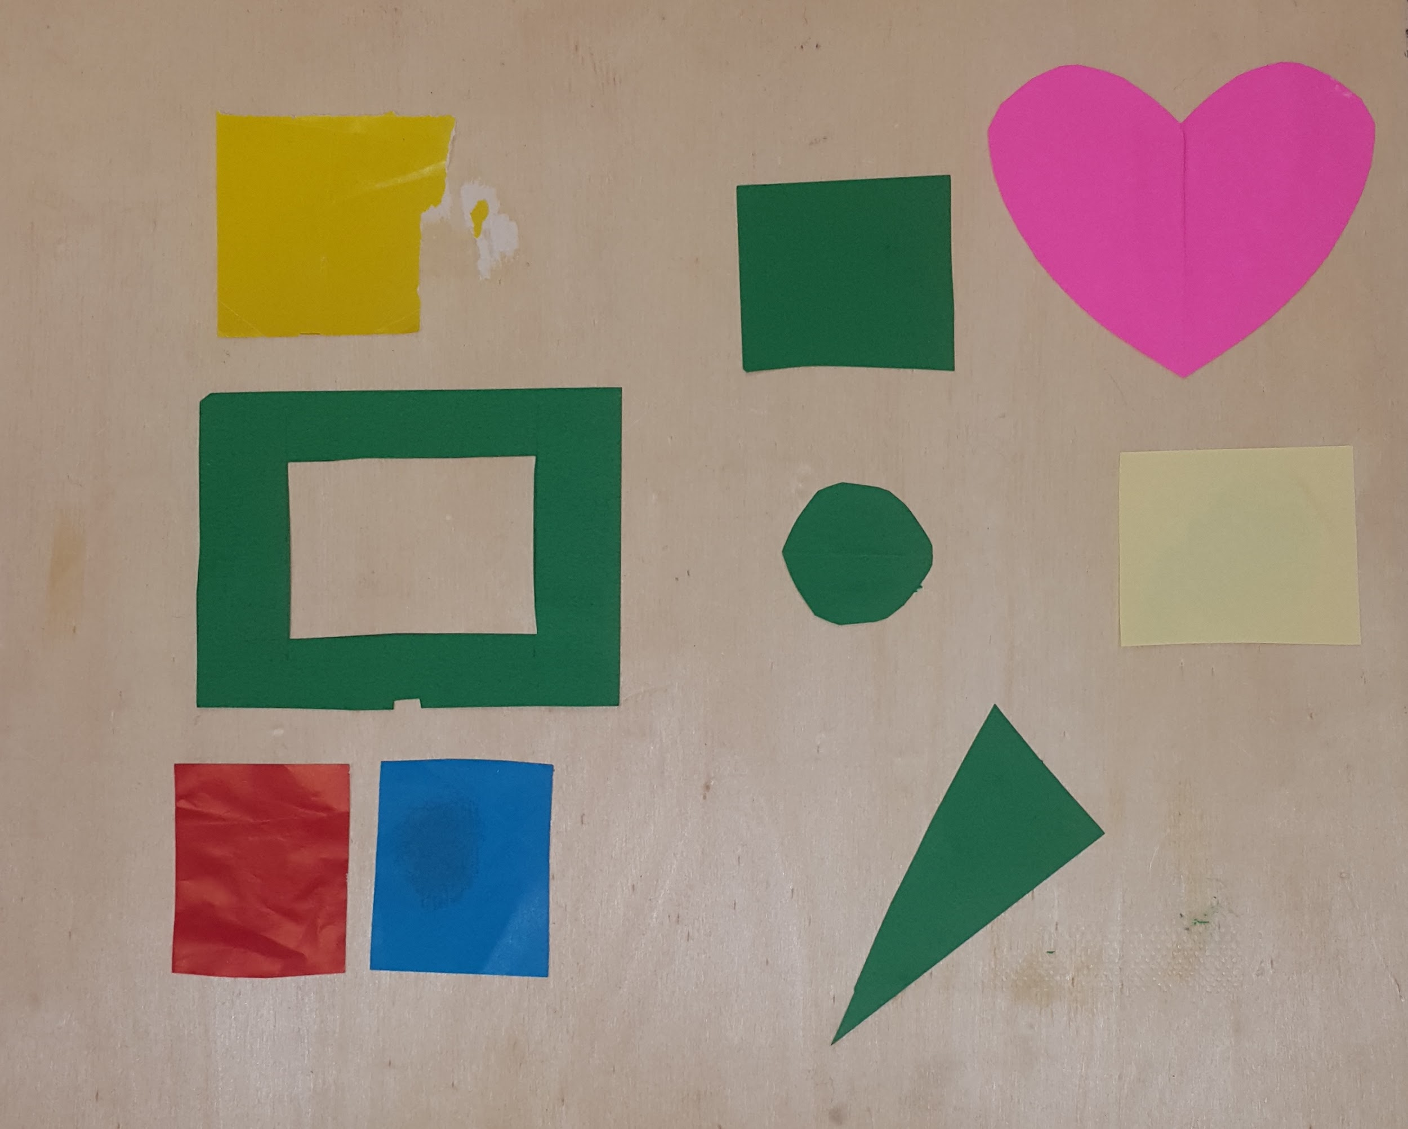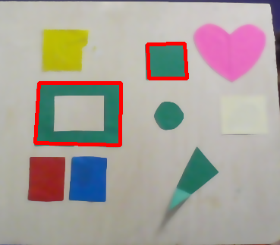

**Figure 11:** Subjects entered the test vs. subjects detected

**Conclusion:** Only green rectangles or shapes similar to rectangle should be detected.

### Accuracy and precision of distance, direction and orientation.

**Test Procedure:**

* Distance
  + - Place the visibility marker (mock up) at 7 different positions.
    - Measure the actual distance using ruler.
    - Observe the distance output of image processing module.
    - Repeat the experiment 3 times.
* Direction angle
  + - Place the visibility marker (mock up) at 7 different angles from the robot.
    - Measure the relative direction angle physically.
    - Convert it to our scale (-100 to +100).
    - Observe the direction angle output of image processing module.
    - Repeat the experiment 5 times.
* Orientation angle:
  + - Rotate the visibility marker (mock up) clockwise or anti clockwise.
    - Measure the relative orientation angle physically.
    - Convert it to our scale (-100 to +100).
    - Measure the orientation angle output of image processing module.
    - Repeat the experiment 5 times.

**Test Results:**

DISTANCE:

|  |  |  |  |
| --- | --- | --- | --- |
| **Actual Distance (cm)** | **Data for the first test (cm)** | **Data for the second test (cm)** | **Data for the third test (cm)** |
| **20** | 19.70 | 20 | 19.63 |
| **25** | 25.10 | 24.90 | 25.11 |
| **30** | 29.60 | 29.51 | 29..47 |
| **35** | 35.55 | 35.51 | 35.48 |
| **40** | 40.65 | 40.31 | 40.33 |
| **45** | 45.13 | 44.80 | 44.47 |
| **50** | 50.10 | 49.60 | 49.58 |

**Table 2:** Results for the distance

DIRECTION:

|  |  |  |  |
| --- | --- | --- | --- |
| **Actual Angle (degrees)** | **Test1(scaled -100 to 100)** | **Test2(scaled -100 to 100)** | **Test3(scaled -100 to 100)** |
| **30** | -77 | -74 | -75 |
| **45** | -58 | -60 | -60 |
| **75** | -37 | -36 | -39 |
| **90** | 0 | 1 | 0 |
| **150** | 37 | 38 | 37 |
| **135** | 57 | 59 | 58 |
| **105** | 79 | 77 | 80 |

**Table 3:** Results for the direction

ORIENTATION:

|  |  |  |  |
| --- | --- | --- | --- |
| **Actual Angle (degrees)** | **Test1(scaled -100 to 100)** | **Test2(scaled -100 to 100)** | **Test3(scaled -100 to 100)** |
| **30** | -78 | -76 | -77 |
| **45** | -60 | -63 | -61 |
| **75** | -38 | -39 | -39 |
| **90** | 0 | 0 | -1 |
| **105** | 32 | 34 | 33 |
| **135** | 55 | 57 | 54 |
| **150** | 76 | 78 | 79 |

**Table 4:** Results for the orientation

**Conclusion:** The measured values for distance are are within +2% error margin. For orientation and direction, the values are scaled from -100(0 degrees) to -100(180 degrees), where 0 is 90 degrees.

## Distance Sensors

Two different types of distance sensors are used to detect distance.

### IR Distance Sensor

**Objective:** Reliable distance measurement

**Possible sources of errors:**

* Stray IR Radiation

**Test Procedure:**

* IR distance sensor is placed.
* A wide blocking flat object is placed in front of the sensor.
* The object is placed at different distances from the sensors.
* The value read by the sensor is measured and tabulated.
* Experiment is repeated three times with different objects.

**Test Results:**

|  |  |  |  |
| --- | --- | --- | --- |
| **Actual Distance (cm)** | **Data for the first test (cm)** | **Data for the second test (cm)** | **Data for the third test (cm)** |
| **15** | 15.70 | 15.60 | 15.58 |
| **20** | 19.48 | 19.56 | 19.53 |
| **25** | 24.50 | 24.50 | 24.60 |
| **30** | 30.52 | 30.50 | 30.47 |
| **35** | 35.51 | 35.50 | 35.48 |
| **40** | 40.22 | 40.30 | 40.34 |
| **45** | 45.45 | 45.40 | 45.47 |
| **50** | 50.63 | 50.60 | 50.58 |
| **55** | 55.75 | 55.70 | 55.81 |
| **60** | 61.10 | 61.00 | 60.78 |

**Table 5:** Results for the IR distance sensor

**Conclusion:** Based on the requirements of the project, the collected data prove that the sensor provides satisfactory performance.

### Ultrasonic Distance Sensor

**Objective:** Reliable distance measurement

**Possible sources of errors:**

* Stray Sound Radiation

**Test Procedure:**

* The sensor is placed.
* A wide blocking flat object is placed in front of the sensor.
* The object is placed at different distances from the sensors.
* The value read by the sensor is measured and tabulated.
* Experiment is repeated three times with different objects.

**Test Results:**

|  |  |  |  |
| --- | --- | --- | --- |
| **Actual Distance (cm)** | **Data for the first test (cm)** | **Data for the second test (cm)** | **Data for the second test (cm)** |
| **15** | 16 | 15 | 16 |
| **16** | 17 | 16 | 17 |
| **17** | 18 | 17 | 18 |
| **18** | 19 | 18 | 19 |
| **19** | 20 | 19 | 20 |
| **20** | 21 | 20 | 21 |
| **21** | 22 | 21 | 22 |
| **22** | 23 | 22 | 23 |
| **23** | 24 | 23 | 24 |
| **24** | 25 | 24 | 25 |
| **25** | 26 | 25 | 26 |
| **26** | 27 | 26 | 27 |
| **27** | 28 | 27 | 28 |
| **28** | 29 | 28 | 29 |
| **29** | 30 | 29 | 30 |
| **30** | 31 | 30 | 31 |
| **35** | 36 | 35 | 36 |
| **40** | 41 | 40 | 41 |
| **45** | 46 | 45 | 46 |
| **50** | 51 | 50 | 51 |
| **55** | 56 | 55 | 56 |
| **60** | 61 | 60 | 61 |

**Table 6:** Results for ultrasonic distance sensor

**Conclusion:** Based on the requirements of the project, the collected data prove that the sensor provides satisfactory performance.

## Solar Panel

**Objective:** To detect the last robot

**Possible sources of errors:**

* Light from environment

**Test Procedure:**

* Solar panel is connected to a multimeter.
* Different types of light are applied to the solar panel.
* Voltage between the terminals of the panel is measured.

**Test Results:**

|  |  |  |
| --- | --- | --- |
| **Light source** | **Voltage from 10 cm (V)** | **Voltage from 20 cm (V)** |
| **Torch** | 0.28 | 0.11 |
| **Flashlight of a phone camera** | 0.40 | 0.24 |
| **Laser** | 0.60 | 0.60 |

**Table 7:** Results of the solar panel test

**Conclusion:** It is true that the environmental light may affect the solar panel; however, regarding the magnitude of the voltage created by the laser, by having a threshold value and comparing it with the voltage of the solar panel, it is possible to use the component to fulfill the desired task.

## Robot Speed

**Objective:** To fulfill the minimum speed requirement, which is 12 cm/s, and to manage to have sufficient speed to catch other robots if it leaves the line

**Possible sources of errors:**

* Weight
* Uneven surface
* Surface type

**Test Procedure:**

* Robot is placed on different surfaces and switched on.
* The speed is measured.
* A load is added to increase the total weight.
* Again, the robot is placed on different surfaces and switched on.
* The speed is measured

**Test Results:**

|  |  |  |
| --- | --- | --- |
| **Surface type** | **Speed without additional weight (cm/s)** | **Speed with additional load (cm/s)** |
| **Marble** | 39 | 45 |
| **Wood** | 40 | 46 |

**Table 8:** Results of the speed test

**Conclusion:** The results show that the speed of the robot can meet the requirements. It is also sufficient to catch the leading robots if it leaves from the convoy.

## Turning

**Objective:** To satisfy the minimum radius of the route of the convoy and also sharper turns to make necessary maneuvers

**Possible sources of errors:**

* Motors
* Wheels
* Uneven surfaces

**Test Procedure:**

* A code a for pre-programmed route consists of turns with different radiuses for both towards left and right is uploaded to the microcontroller.
* The robot is placed on the ground and switched on.
* The maneuvers the robot makes are observed.
* The tests were repeated on the various test surfaces.

**Test Results:**

|  |  |
| --- | --- |
| **Surface type** | **Maintained 100 cm turning radius** |
| **Marble** | Successful |
| **Wood** | Successful |
| **Uneven Surface** | Successful |

**Table 9:** Results for the turning

**Conclusion:** The robot is capable to perform both sharp and wide turns for both towards left and towards right. The controller library, wheels and motors can perform required maneuvers.

## Leaving

**Objective:** To make the robot perform the maneuver as soon as possible after giving the command.

**Possible sources of errors:**

* Ambient noise

**Test Procedure:**

* The robot is placed on the ground and switched on.
* A signal is transmitted to the robot by an IR remote control.
* The test was also conducted with infrared output of a remote in pointed towards the receiver.

**Test Results:**

|  |  |
| --- | --- |
| **Surface type** | **Response Time** |
| **No Noise** | <1s |
| **IR remote Noise** | <1s |

**Table 10:** Results for the leaving test

**Conclusion:** The time is measured by a stopwatch. Therefore, the results could only be made accurate to the nearest 10th of the second considering the human reaction time. However, it is observed that the response time is less than 1 second which satisfies the requirements.

## Following

**Possible sources of errors:**

* Not having a radial emission from the IR LED
* Not able to detect the IR light by the sensor located at the far edge

**Test Procedure:**

* Two IR sensors are located on different sides of a rectangle protoboard symmetrically.
* Data are recorded from different distances and angles.
* The robot is placed on the ground and switched on.
* The mock up with IR actuator is moved in front of the robot and its response is observed.

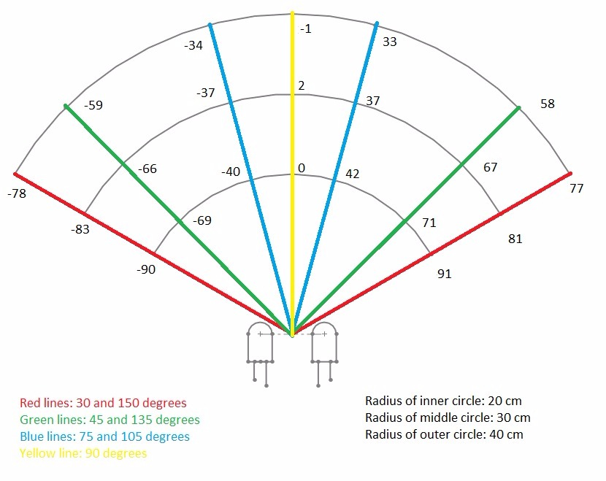

**Figure 12:** Test procedure for the direction sensor

**Test Results:** Data read by sensors are symmetric. The robot can follow the leading robot. Note that the values indicated in the Figure 12are converted to a scale from -100 to 100.

**Conclusion:** The proposed method for detecting the robot in front fulfills the requirements. By processing data, it is observed that the task is performed.

## Power Delivery

**Objective:** To be able to supply the required power to the robot for at least 5 minutes.

**Possible sources of errors:**

* Ambient Temperature of the room
* Activity of the mockup robot

**Test Procedure:**

* The robot it let to follow the mockup robot.
* The battery percentage is calculated after 5 minutes of activity.
* Test was repeated for different activity levels of the robot.

**Test Results:**

|  |  |
| --- | --- |
| **Surface type** | **Battery Percentage after Test** |
| **High Activity** | 40 % |
| **Low Activity** | 50 % |

**Table 11:** Results of the power test

**Conclusion:** The power delivery system has proved itself capable to provide the required amount of energy for the demonstration.

# DELIVERABLES

* The robot (with a removable cover)
* Battery
* Remote control
* User manual
* Technical specification sheet

# BUDGET

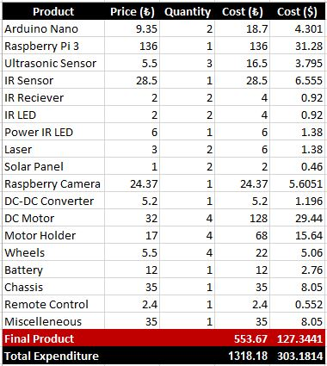

**Table 12:** Budget analysis for the project

In Table 12, the budget analysis for the final product can be seen. As can be seen on final product cost, the limit has not been exceeded.

Two Arduinos are used because due to the requirements of the project, lots of pins are required. For this reason, the least expensive choice is made and it is decided to use Arduino Nanos. For image processing, Raspberry Pi 3 is the cheapest one which satisfies the requirements. For the camera, a very good offer was found. The Raspberry camera is a lot cheaper than most of the alternatives. For the other components such as motors, sensors and actuators, among the ones which satisfy the requirement and have a decent performance, the best price was tried to be found.

The total cost including engineering and infrastructure costs can also be observed on Table 12**.**

# IMPACTS OF THE ROBOT

## Safety Issues

### Lasers

The device uses lasers on both sides to broadcast information to the rest of the convoy. Care must be taking when operating the robot as the laser can cause damage to the eye. Please use the reserved button (mode) on the remote to disable the laser. Please make sure to reenable the laser when using the robot otherwise the robot shall not function as intended. The reserved button can be seen in Figure 13.

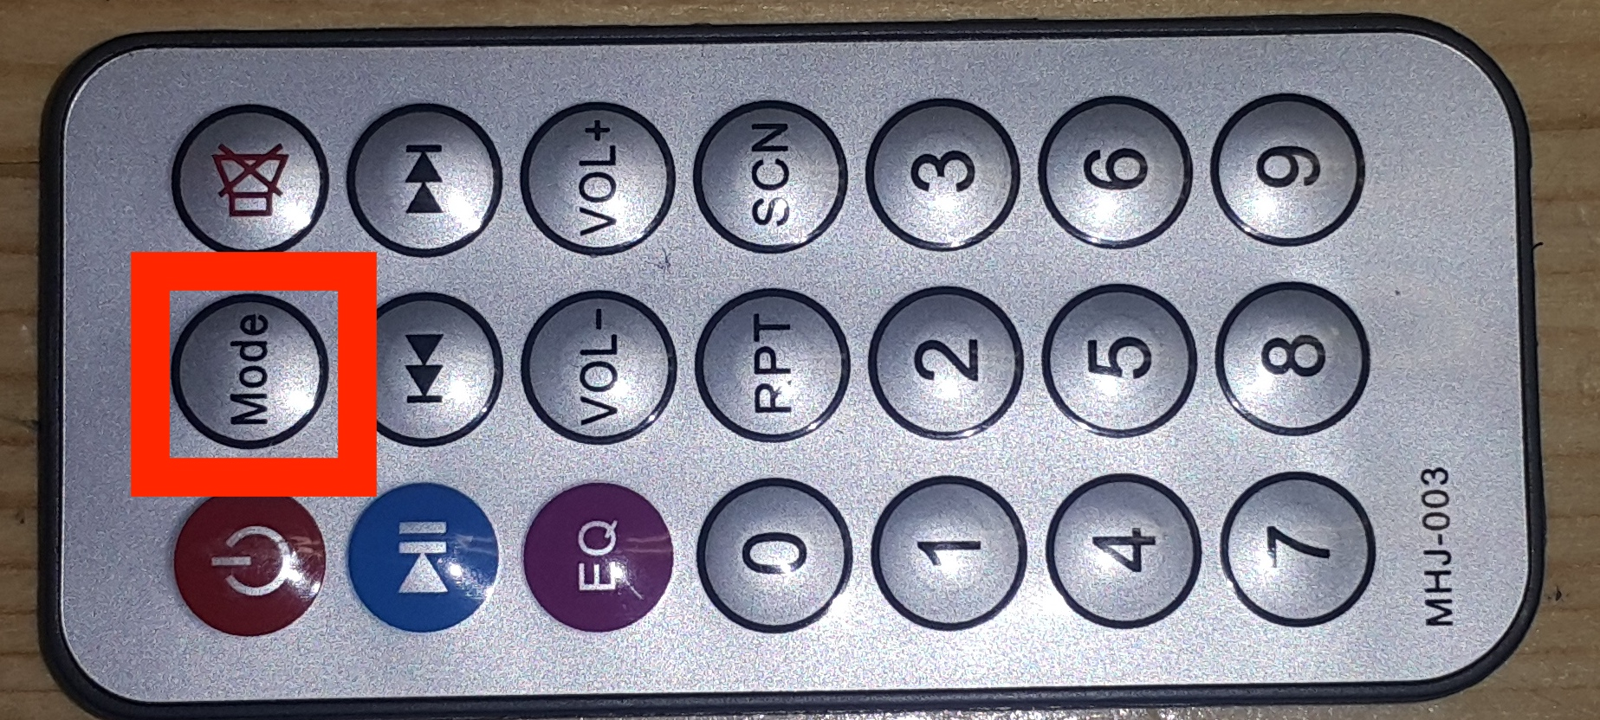

**Figure 13:** The reserved button for the lasers

### Fire hazard

The robot is made out of MDF and therefore has has the capability to catch on fire. Do not leave the robot in direct sunlight and do not use near open flame.

## Widespread Applications

### Virtual Sensor

Our implementation of the robot uses a virtual sensor object. The virtual sensor is assumed to have all the required information we can that may be required such as distances from other robot, flag status etc. This method allows for the rest of the code to be completed without having exact information about the detail of the actual hardware of the sensor. It allows the integration information from multiple actual sensors that measure the same information. This system of abstraction can be used in other projects to allow an efficient implementation.

### Image Processing

During the implementation of the image processing algorithms a lot of research has been conducted to accurately and efficiently detect rectangular object of a particular color. The optimization of color thresholding to work in different lighting conditions. Furthermore, algorithms have been written to get parameter about the rectangle by processing the coordinates of the rectangle. For the project the relative distance, relative direction and orientation is determined. Such algorithms can be incredibly useful for following applications. For example a drone can be programmed to autonomously take shots of a object with a rectangular marker attached.

### Communication

For communication between the raspberry pi and arduino a custom fast encoding system was designed. The protocol can be brought into mainstream use for projects with similar requirements. The protocol requires minimal cpu resources to decode and can be customised easily according to user requirements.

## Environmental Impact

### Autonomy of the Car

The autonomous driving aspect of our robot can also be considered as a widespread application. For the implementation of our project, the robot has access to information about its surrounding such as distance from its surrounding. With this information, by improving the algorithm and making it applicable the more general conditions, it is possible to avoid lots of collision caused by human errors while driving. Our robot can be used to improve artificial intelligence as a small model of a real car. With this feature, not only the human lives will be saved but the animals in the nature will be protected as well.

### Choice of Materials

The components have been chosen to be environmentally friendly. Not only the bulk of the robot is made out of renewable materials, the robot is also biodegradable and recyclable. When mass produced the choice choise of materials that the company has made make sure that the production does not have a negative impact on the environment.

# CONCLUSION

OJO consists of five productive, hardworking and dedicated engineering students. These qualities also reflects to our work. The hard work and effort we put on our design can be observed from the product. We are very confident with the fact that our robot satisfies all the requirements and the standards which needs to be fulfilled. To show this, after indicating the design requirements and the observed problems with the solutions offered, for each task, the tests which were conducted are explained in detail and their results are provided. Furthermore, the design is also very compact and user friendly. Moreover, even though there are not too many instructions in the user manual, they are supported with lots of figures and photos to make them easier to follow. In addition, the deliverables are indicated to make the customers aware of what they should expect. Additionally, the customer are also warned about the potential misuse of the product, and the precautions need to be taken are also provided.

During the process of designing and implementation of the robot, a lot of experience on different kind of problems are gained by the members of the company. The opportunity for learning new things, working on different problems and trying to come up with alternative solutions was a pleasure for the members. Thus, after the progress we made, we are very confident about the product we made. Furthermore, the excitement and the pleasure we had assures how big our excitement is for the future works.

# APPENDICES

## User Manual

**Warning!**

Do not make an eye contact with the laser!

**Warning!**

The system must be turned off while charging. Please turn off the switch before plugging in the charger. In Figure A1**,** the position of the switch which turns the system on can be seen.

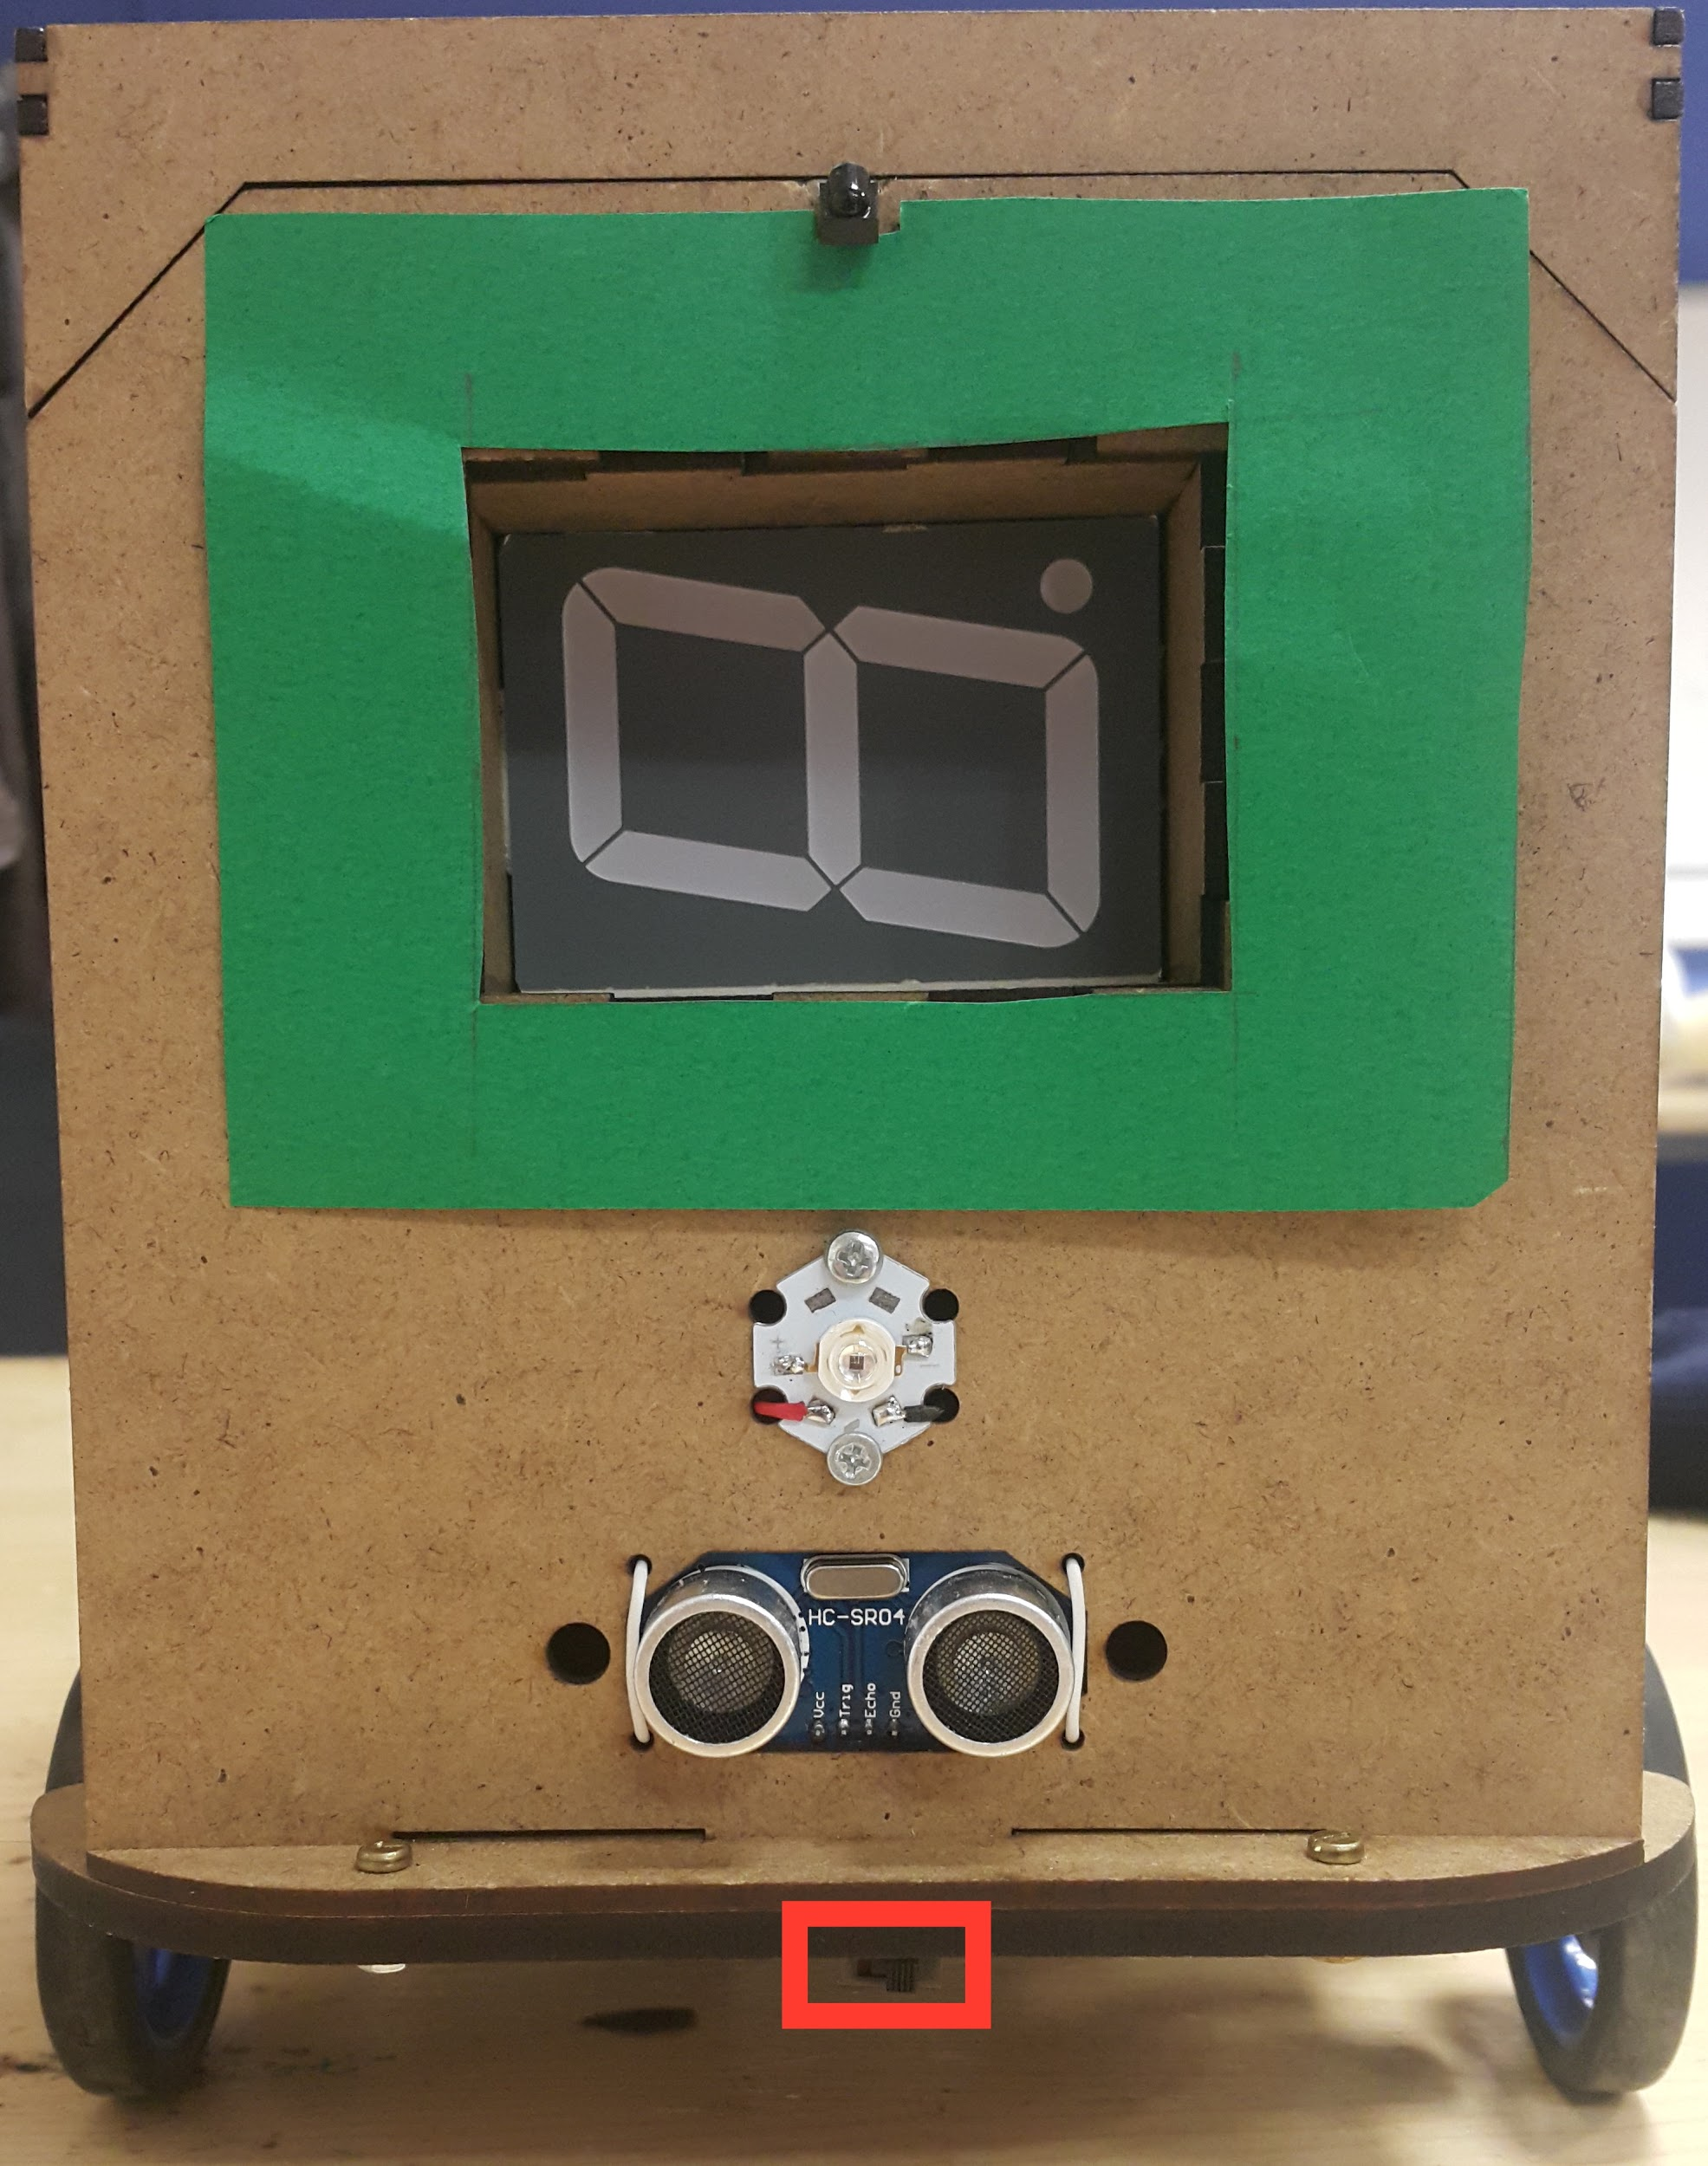

**Figure A1:** Position of the switch

1. Before starting to use the robot, the battery needs to be charged. To reach the battery, please gently remove the cover from the marked spots in Figure A2X.

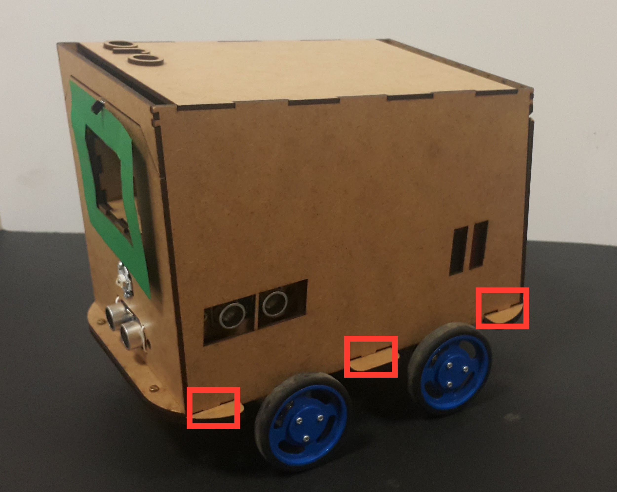

**Figure A2:** Spots to remove the cover

1. Battery connection points can be seen in Figure A3. Connect the positive end to the red terminal and the negative end to the black terminal to charge the battery. **14.4 Volts** must be supplied.

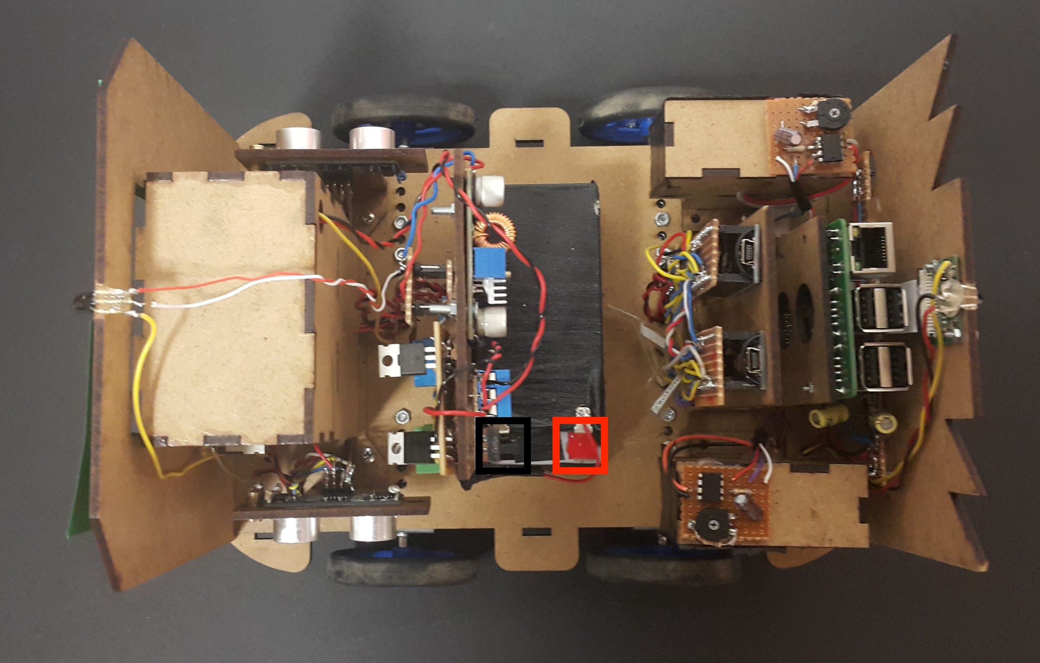

**Figure A3:** Battery connection points

1. After the battery is fully charged, please put the cover on the chassis from the points indicated in Figure A2.
2. The robot is ready to work. Place it in the convoy as indicated in Figure A4. Turn on the switch.

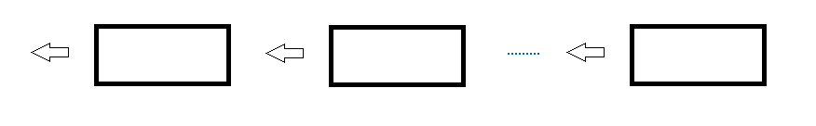**Figure A4:** The proper placement of robots in the convoy to start

1. The robot started to work. To turn it off, again use the same switch.
2. To give the leaving the line command, please push the button indicated in Figure A5 in the remote control.

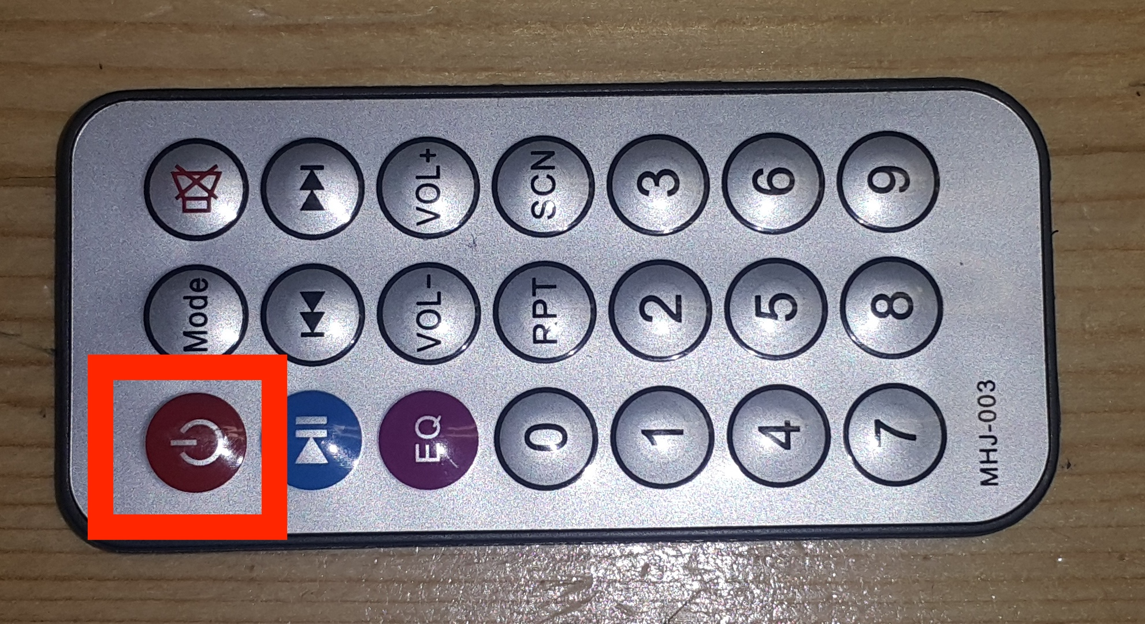

**Figure A5:** The remote control

## Photos of the Robot

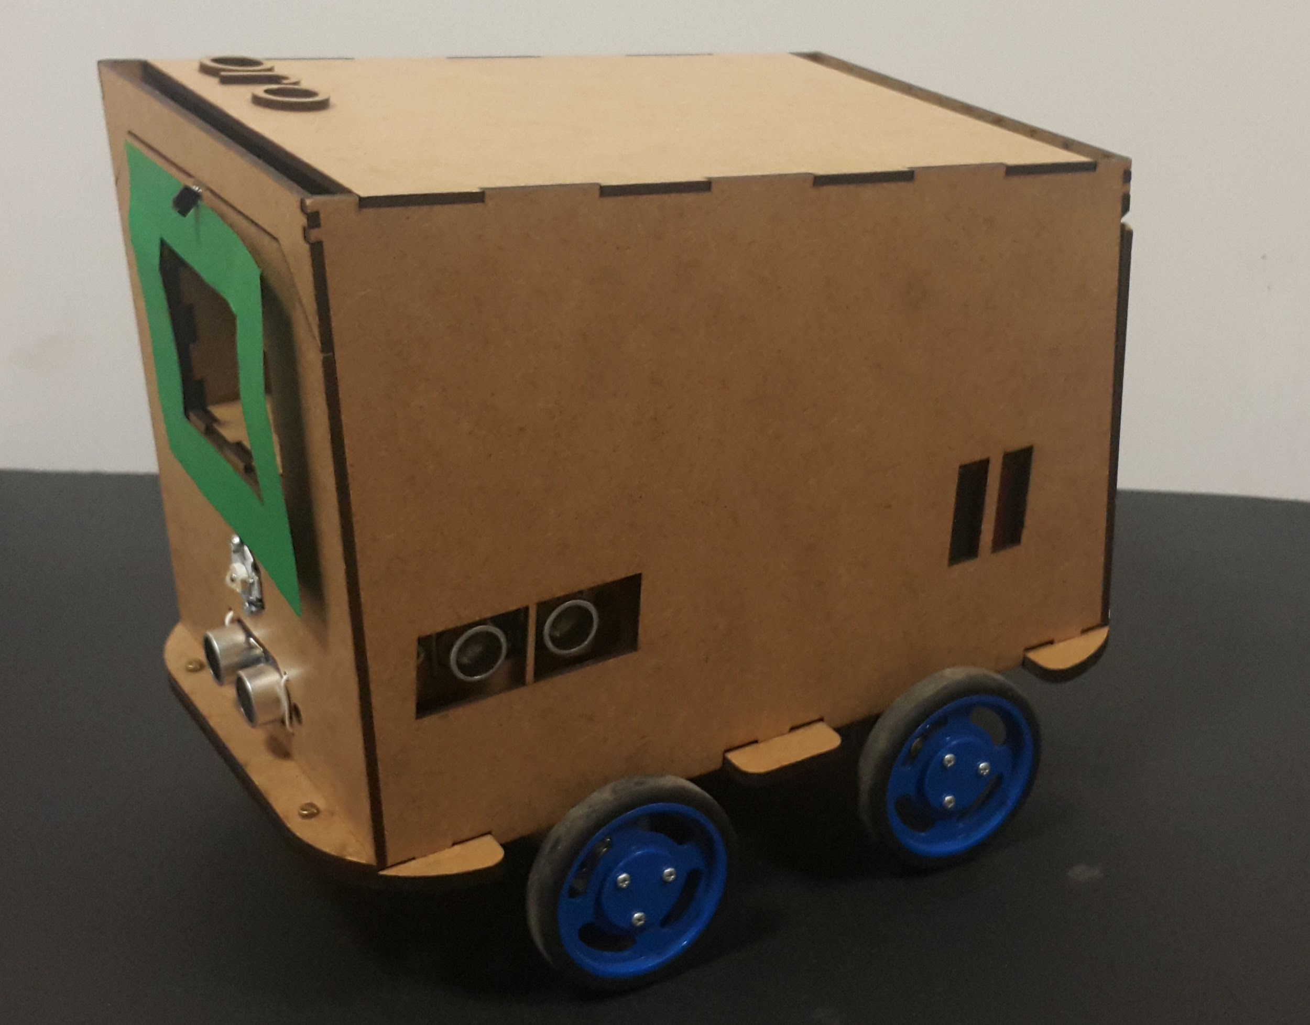

**Figure A6:** Isometric view of the robot with the cover

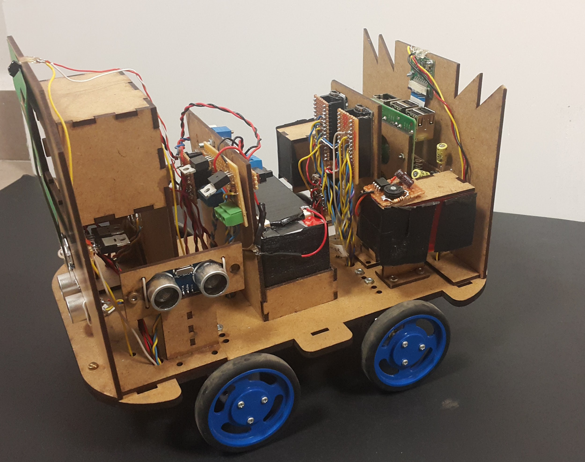

**Figure A7:** Isometric view of the robot without the cover

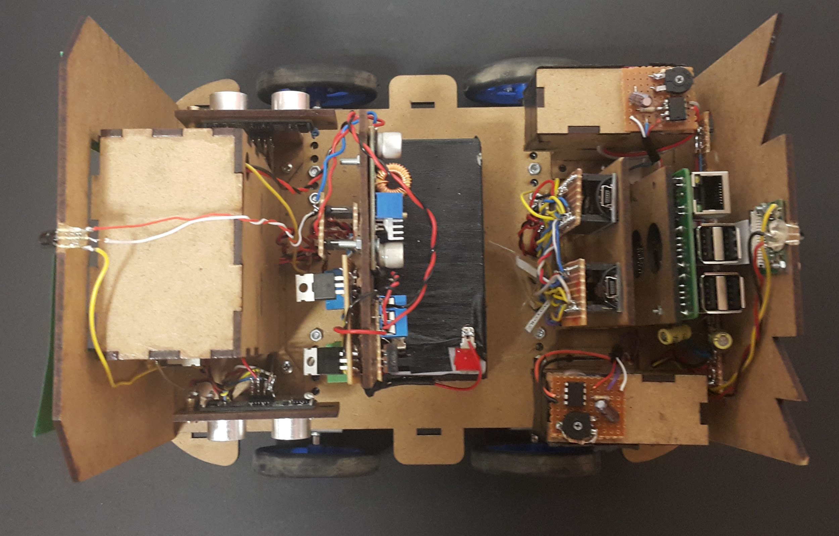

**Figure A8:** Top view of the robot without the cover

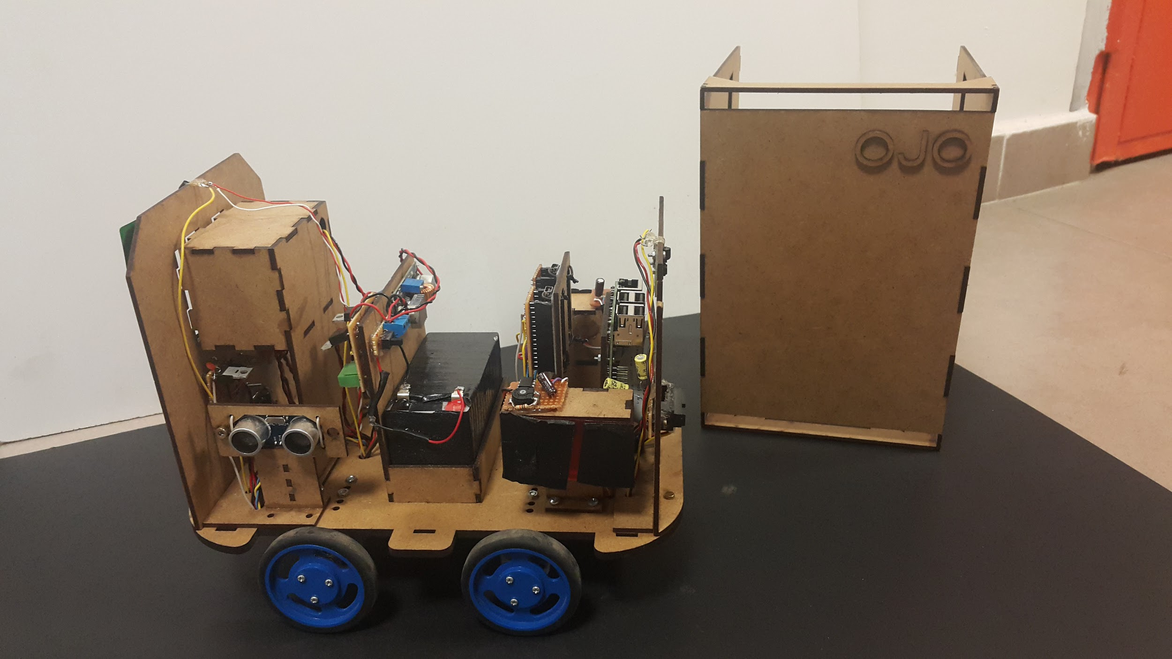

**Figure A9:** A view of the robot and the cover